C01 - AT3 - Flowgorithm
Shainey S
192511378
- Read a student's quiz, assignment, and examination marks. Compute a weighted total of 20%, 30%, and 50% and assign a grade.

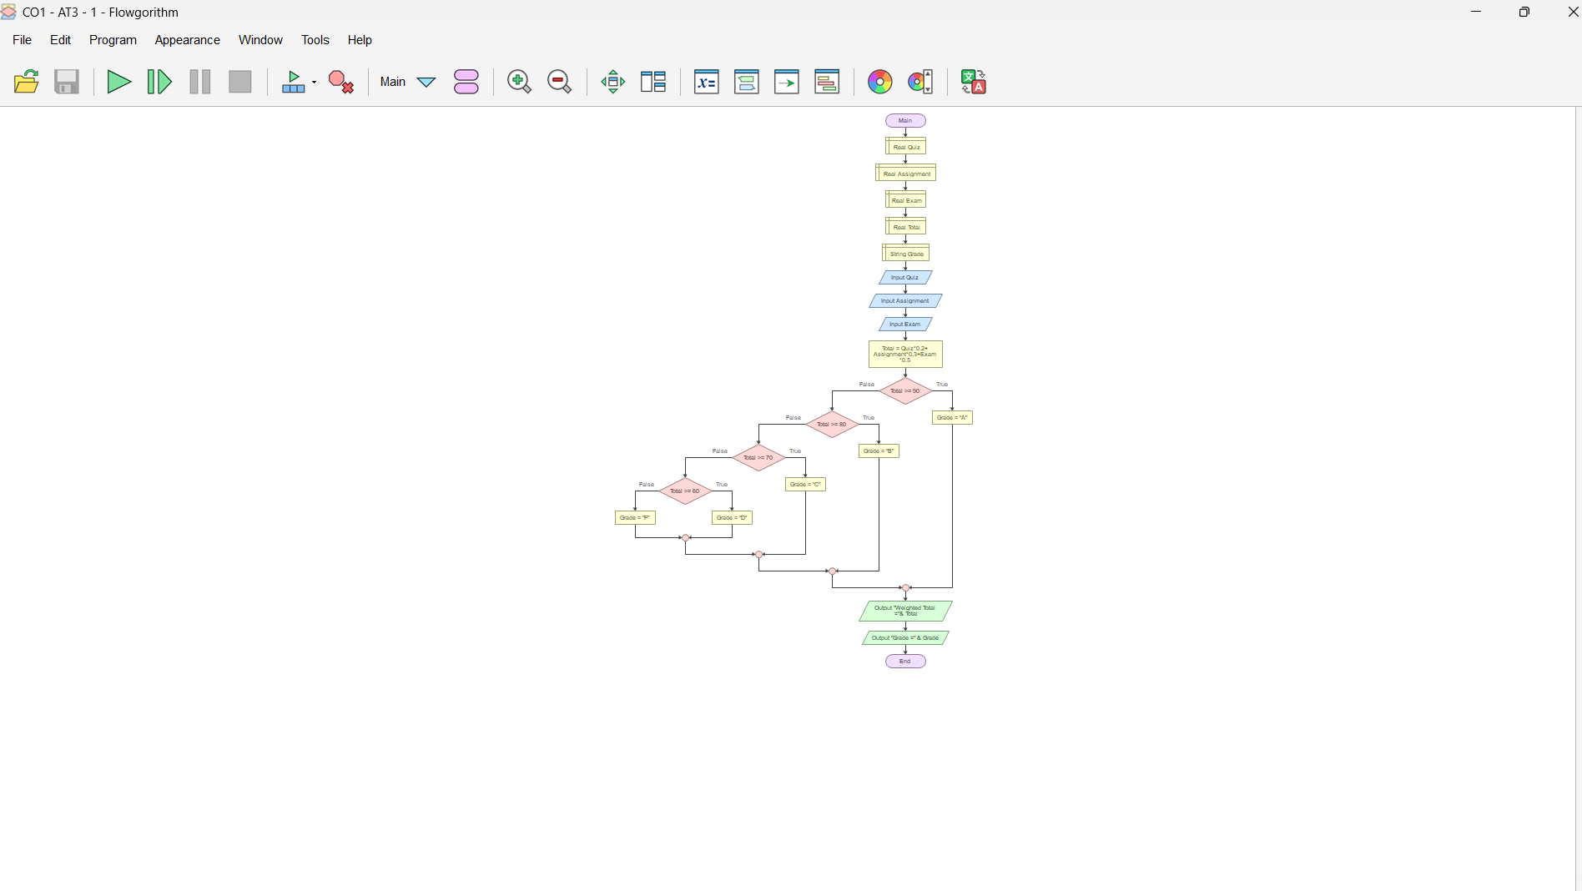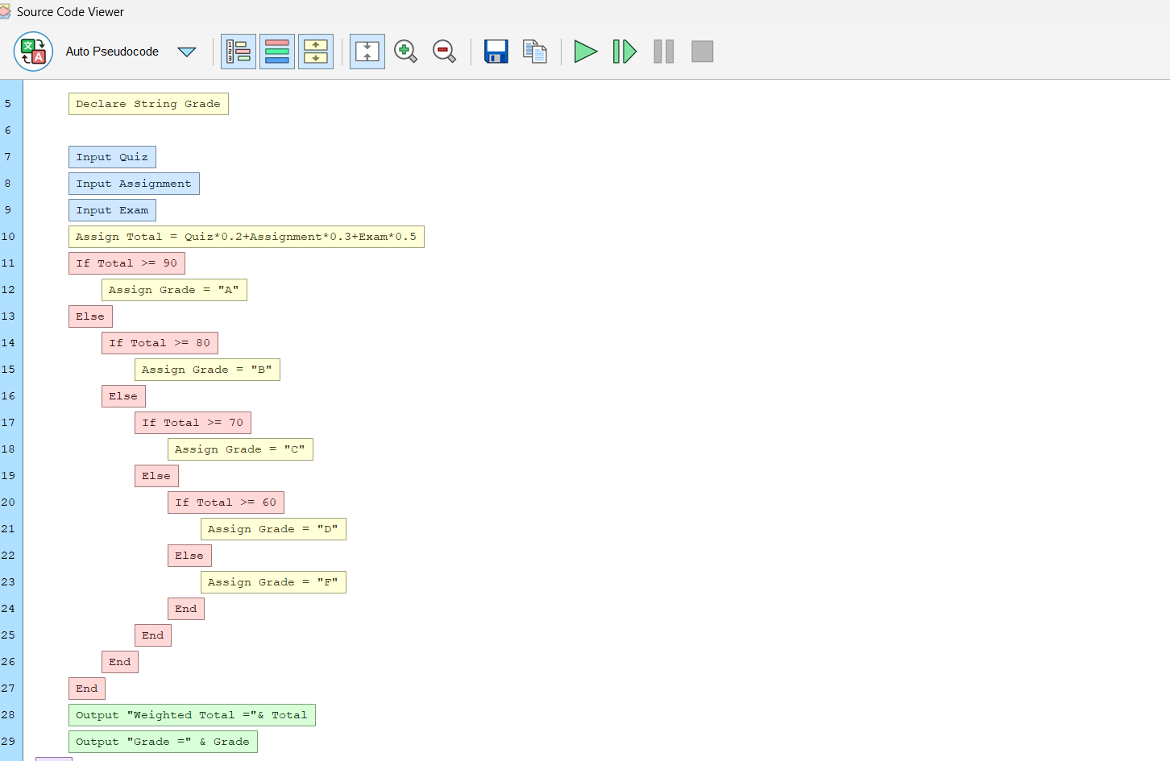
2) Read N integers into an array and display the common values between the first half and second half without repetition.
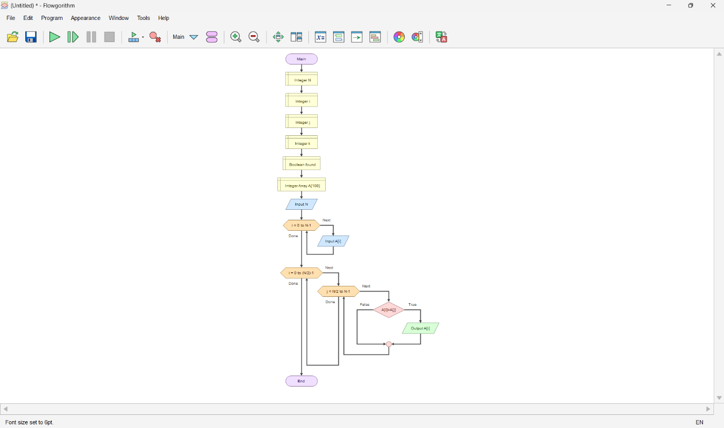
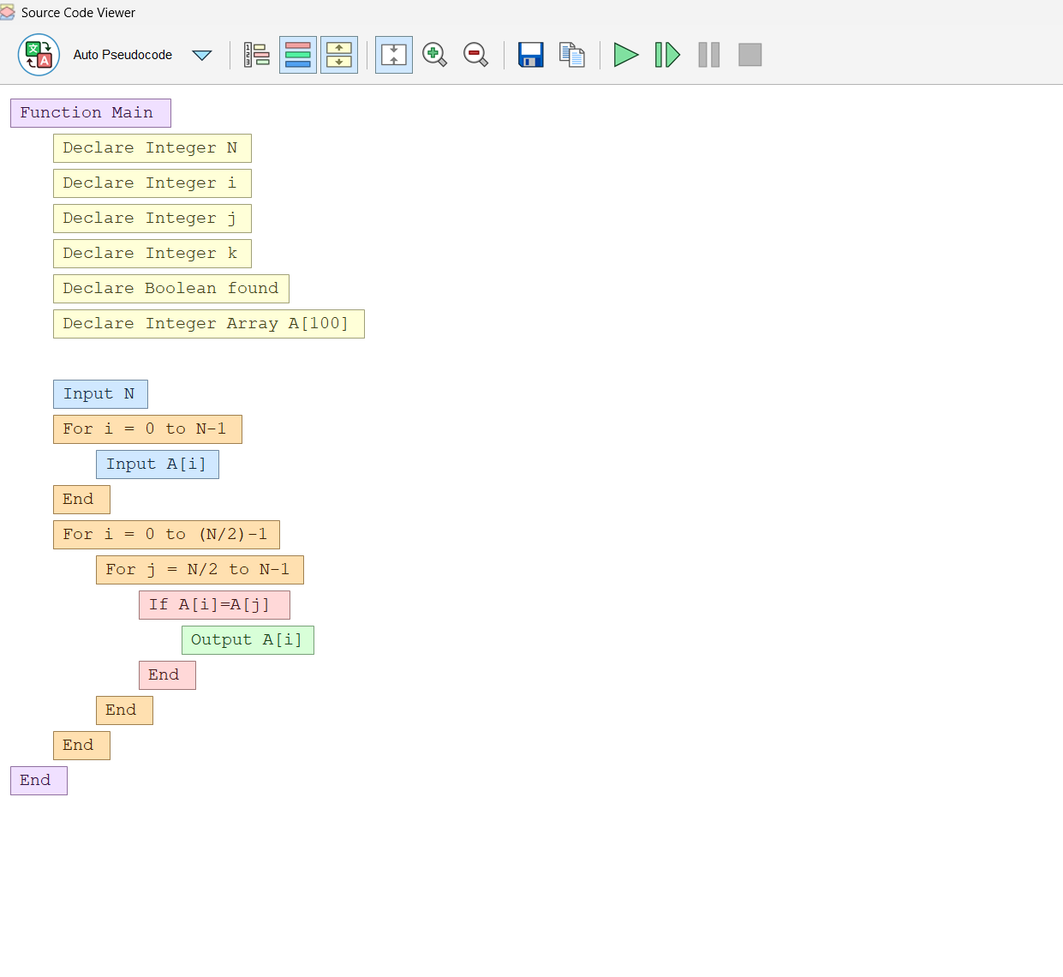

- Create a function decimalToBinary that prints the binary number in correct order using an array for temporary storage.
